Project Title
Global COVID-19 Vaccination Trends Across Continents (2020–2023)
Public Health Question
What are the differences in COVID-19 vaccination coverage across continents between 2020 and 2023, and what patterns emerge when comparing total vaccinations per hundred population?
Breakdown:
• Population: Residents of each continent
• Outcome: Total vaccinations per 100 people
• Time period: 2020–2023
• Comparison: Differences between continents
Why This Question Matters
COVID-19 vaccination remains one of the most important global strategies for preventing severe disease and death. Understanding how vaccination coverage differs across continents helps identify inequities in global health resource distribution. These findings can guide policy, improve preparedness, and strengthen future pandemic responses.
Data Sources
Our World in Data COVID-19 Dataset
Variables Used
Outcome Variable:
- Total vaccinations per hundred
Exposure / Predictors:
- Continent
- Time (year, month)
Stratifiers:
- None used in this analysis, but optional: income level, region

Methods
- Software: Python (Pandas, Matplotlib)
- Data Cleaning:
  - Removed NaN values
  - Aggregated vaccination data by continent
  - Extracted maximum vaccination per hundred for each continent
- Analysis Steps:
  - Grouped data by continent
  - Calculated summary statistics
  - Created visualizations (bar charts and line charts)
- Visualization:
  - Bar chart comparing total vaccinations per hundred
  - Time-series line plots (optional for future analysis)
Results
Key Findings (Bullet Points)
- Europe had the highest vaccination rate (204.93 per 100).
- South America and North America also recorded high coverage (193.26 and 168.72 per 100, respectively).
- Africa had the lowest vaccination coverage (35.31 per 100).
- Large global disparities suggest unequal access to vaccines between high-income and low-income regions.
Figures / Tables:
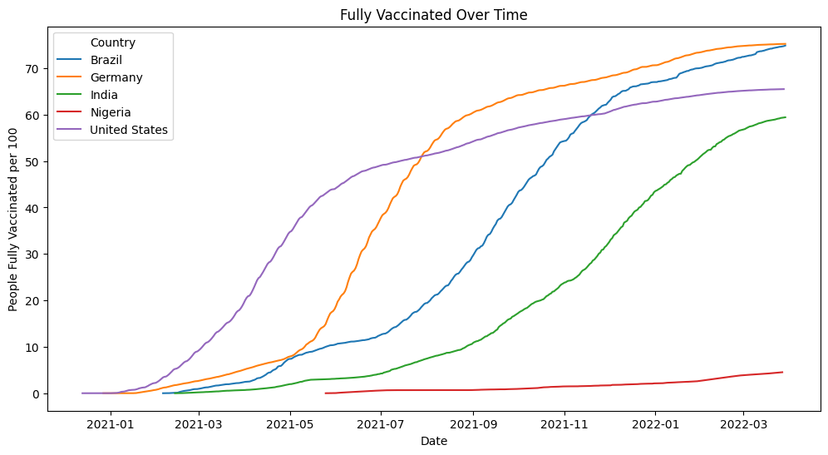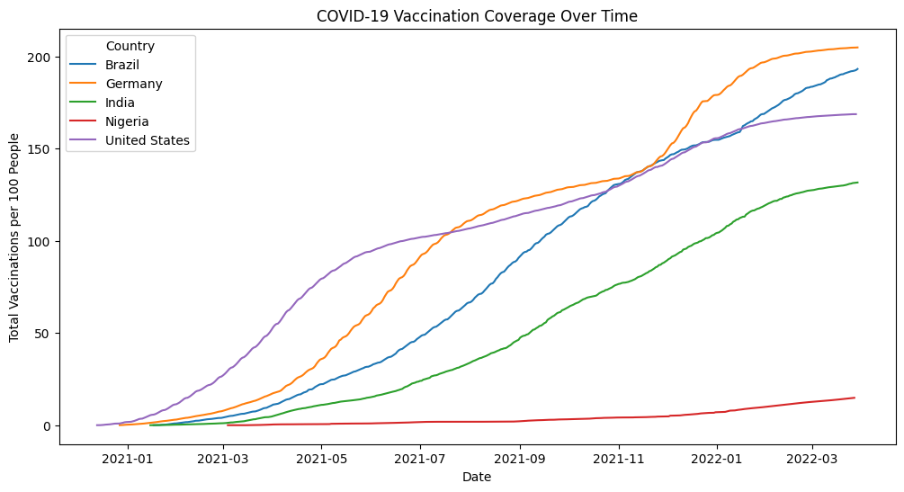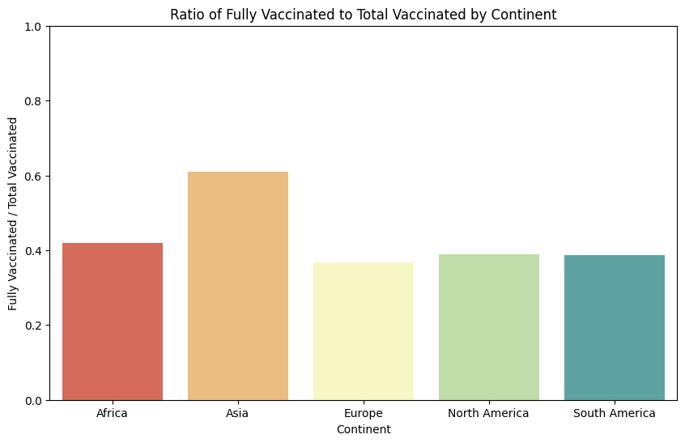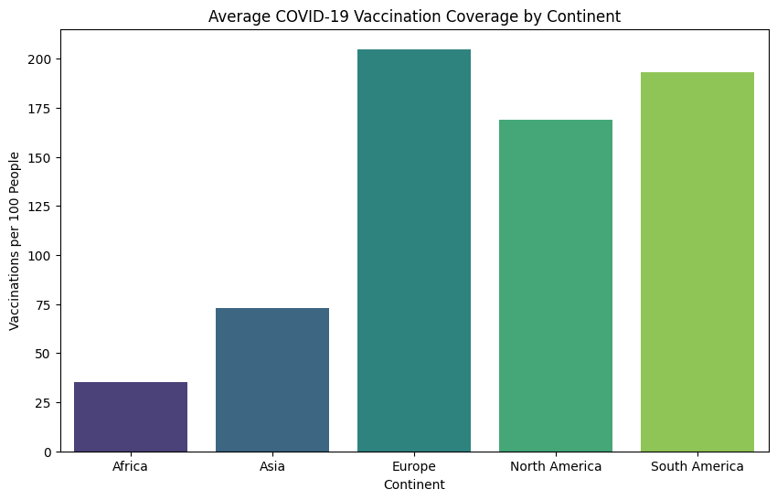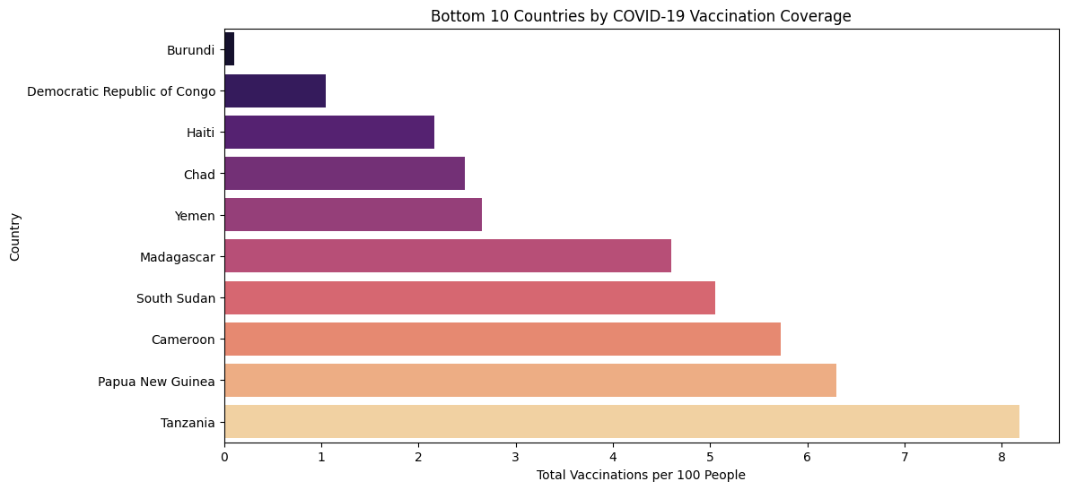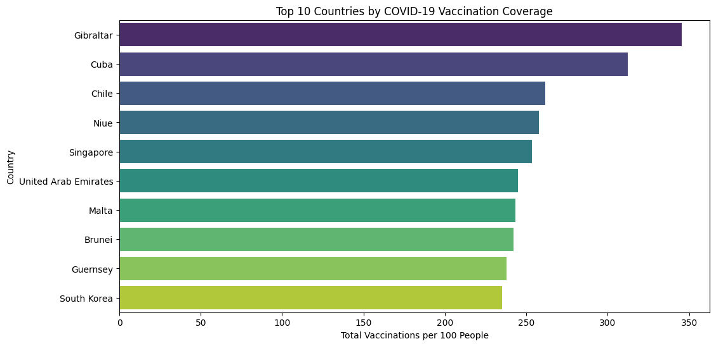
Interpretation Provide clear reasoning
The results show a clear global vaccination inequality. Continents with higher economic power and stronger health systems achieved faster and broader vaccination coverage. Africa’s low coverage may reflect issues such as vaccine access, hesitancy, logistics challenges, and reliance on donations. These findings highlight the need for better global coordination and improved vaccine manufacturing capacity in low-income regions.
Limitations Examples:
- Missing data for some countries and dates
- Continent-level aggregation hides within-continent disparities
- The analysis does not include covariates such as GDP, vaccine supply, or health system strength
- Potential reporting delays during the pandemic
Next Steps Template
- Analyze vaccination coverage by income level (low, middle, high-income countries)
- Compare vaccination trends over time (2020–2023)
- Explore the relationship between vaccination rate and COVID-19 mortality
- Evaluate structural factors driving inequity such as vaccine donations, supply chain limits, and local policy differences
Reproducibility Checklist
- Code uploaded to GitHub
- Data cleaning documented
- Figures generated from Python script
- README written
- One-page non-technical summary

